Revolutionizing Campus Navigation: A Video-Enriched Exploration of SUMAP for an Enhanced College Navigation System"
Vishal Kumar
Department of Enginnering And Technology
2022374254.vishal@sharda.ac.in
Sharda University 201308

Surbhi Rawat
Department of Enginnering And Technology
2022386874.surbhi@sharda.ac.in
Sharda University 201308
Ashish Kumar
Department of Enginnering And Technology
2022360778.ashish@sharda.ac.in
Sharda University 201308

Ankit Pandey
Department of Enginnering And Technology
2022801407.ankit@sharda.ac.in
Sharda University 201308
Sharda University 201308
Sharda University 201308

ABSTRACT

In the contemporary digital landscape, the process of selecting higher education institutions undergoes a transformative paradigm shift with the advent of a sophisticated and user-centric website harnessing the immersive power of videos. This pioneering platform offers a comprehensive collection of meticulously curated, location-specific videos, providing unparalleled insights into colleges and universities worldwide. Departing from conventional static resources, this website empowers users to make meticulously informed decisions by offering a captivating preview of campus life, state-of-the-art facilities, and the overall academic environment. Through a suite of interactive features including augmented reality, seamless social integration, and hyper-personalized recommendations, users are seamlessly facilitated in navigating the college selection process with unprecedented efficiency and efficacy. This research paper undertakes a comprehensive exploration into the intricate architecture, multifaceted functionalities, and profound implications of the "College Navigation Using Videos" system, making a seminal contribution to the ongoing discourse on educational technology and digital media exploration in higher education.
Keywords: College navigation, videos, augmented reality, user interface, personalized recommendations, educational technology.

Introduction
In an epoch defined by the pervasive influence of digital platforms, the quest for higher education stands poised for a transformative revolution. Traditional modalities of discovering colleges and universities predominantly rely on static resources such as brochures and websites, affording limited insights into the vibrant tapestry of campus life and facilities. However, the advent of the "College Navigation Using Videos" system heralds a new era, ushering in a dynamic and immersive paradigm enriched with meticulously curated, location-specific video content.
This research paper embarks on a scholarly odyssey to unravel the intricate tapestry of the "College Navigation Using Videos" system, delving into its architectural intricacies, multifaceted functionalities, and far-reaching implications for the future trajectory of higher education. Through a judicious synthesis of existing literature,
meticulous examination of patent claims, and meticulous scrutiny of detailed descriptions of the invention, this paper endeavors to illuminate the transformative potential inherent in educational technology and digital media exploration in the realm of college navigation.

Literature review
The concept of harnessing multimedia technology to enrich the college exploration process has garnered considerable scholarly attention in recent years. Platforms such as Campus Tours and You Visit have pioneered the dissemination of virtual tours and 360-degree videos, providing prospective students with immersive glimpses into the sprawling expanse of college campuses. While these platforms have undeniably enriched the prospective student experience, the "College Navigation Using Videos" system propels this paradigm to unprecedented heights by integrating immersive features such as augmented reality and hyper-personalized recommendations, thereby elevating the user experience and decision-making process to unparalleled heights .Scholars have underscored the pivotal significance of user engagement analytics in optimizing digital platforms for educational purposes. By meticulously tracking and analyzing user interactions, educational technology developers are empowered to tailor their offerings in alignment with the nuanced preferences and exigencies of users. The incorporation of user profiles within the "College Navigation Using Videos" system not only facilitates hyper-personalized recommendations but also engenders a profoundly tailored user experience, in consonance with the prescient recommendations emanating from extant scholarly literature.

methodology
The methodology employed in this research paper is designed to rigorously examine the "College Navigation Using Videos" system from various perspectives, ensuring a comprehensive understanding of its intricacies and potential impact. The methodological framework comprises several key components, each aimed at shedding light on different aspects of the system.
Firstly, the research begins with a meticulous review of extant literature relevant to educational technology, digital media exploration, and related applications. This literature review serves multiple purposes. It provides a foundational understanding of the broader context in which the "College Navigation Using Videos" system operates, identifies key concepts, theories, and trends relevant to the research topic, and highlights gaps or limitations in existing knowledge that the current study aims to address. By synthesizing insights from diverse sources, the literature review informs subsequent analyses and contributes to the overall theoretical framework of the research.
In addition to the literature review, the research paper undertakes a systematic analysis of patent claims associated with the "College Navigation Using Videos" system. This analysis involves examining existing patents, patent applications, and intellectual property disclosures to identify unique features, innovative functionalities, and proprietary aspects of the system. By scrutinizing patent documents, the research aims to uncover the technological landscape, competitive positioning, and potential legal implications surrounding the development and deployment of the system. This analysis provides valuable insights into the technological innovations underpinning the system and its potential implications for future research and development.
Furthermore, the research paper delves into detailed descriptions of the invention, complementing the analysis of patent claims. This involves a thorough examination of technical specifications, system architectures, and operational mechanisms elucidated in patent documents, research publications, and technical reports. By deconstructing the intricacies of the invention, the research aims to unravel underlying principles, design considerations, and technological advancements driving its development. This rigorous examination offers a deeper understanding of the system's architecture, functionalities, and potential implications for educational practices.
Lastly, the methodology includes an exploration of allied applications and related technological innovations within the domain of educational technology and digital media exploration. This involves identifying synergies, overlaps, and potential collaborations with existing platforms and methodologies aimed at enhancing the user experience, facilitating immersive navigation, and optimizing decision-making processes in the context of higher education. By situating the "College Navigation Using Videos" system within the broader ecosystem of educational technology, the research seeks to elucidate its functional intricacies, transformative potential, and implications for future development and implementation.

Software overview

This Website (ADHD) is created using Squarespace tampletes provides a comprehensive insight into the structure and functionality of the site. CSS provide the foundation, defining the site’s structure and visuals styling, ensuring a clean and responsive design. Squarespace templates offer a user-friendly content management system, simplifying website maintenance and content updates. Together, these elements create a dynamic, visually appealing website that combines the flexibility of code-based with the convenience of a user-friendly plateform, catering to both developers and non-technical users alike.

Working Flowchart

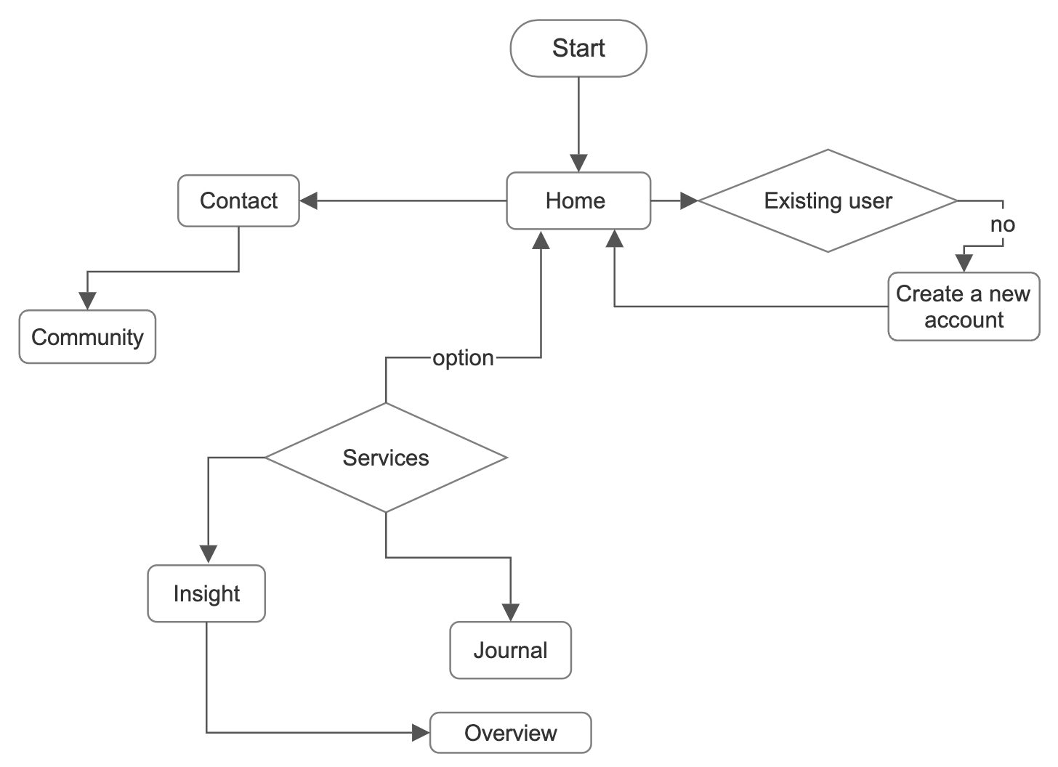

Operational Model Of SUMAP

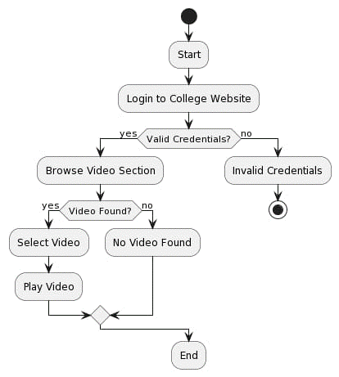

Conclusion
In conclusion, the "College Navigation Using Videos" system represents a groundbreaking advancement in the realm of educational technology, heralding a new era of college exploration and decision-making. Through its immersive and informative platform, enriched with meticulously curated multimedia content, the system offers users a transformative experience that transcends traditional methods of college discovery.
The system's ability to provide users with unprecedented insights into colleges and universities, through location-specific video content, interactive mapping, and personalized recommendations, marks a significant departure from static, text-based resources. By harnessing the captivating allure of videos and cutting-edge technologies, such as augmented reality and user engagement analytics, the system elevates the college exploration process to unparalleled heights.
Moreover, the "College Navigation Using Videos" system holds immense promise for democratizing access to higher education on a global scale. By rendering the college selection process more accessible, informative, and user-friendly, the system empowers aspiring scholars from diverse backgrounds to make well-informed decisions about their academic futures.
As technology continues to evolve at a rapid pace, the potential for further innovation and refinement within the educational technology landscape is boundless. The visionary concept embodied by the "College Navigation Using Videos" system stands as a testament to the transformative power of technology in shaping the future of higher education.
In essence, the system not only revolutionizes the way in which individuals explore and select colleges but also serves as a catalyst for broader societal change, fostering greater inclusivity, accessibility, and empowerment within the educational landscape. As we look towards the future, it is clear that the impact of the "College Navigation Using Videos" system will extend far beyond the confines of the digital realm, leaving an indelible mark on the hallowed precincts of higher education for generations to come.

References
[1] United States Patent and Trademark Office. Retrieved from https://www.uspto.gov/.
[2] IEEE Xplore Digital Library. Retrieved from https://ieeexplore.ieee.org/.
[3] OpenAI. Retrieved from https://chat.openai.com/.
[4] OzCHI'13 Proceedings of the 25th Australian Computer-Human Interaction Conference: Augmentation, Application, Innovation, Collaboration. Retrieved from https://eprints.qut.edu.au/62476/1/ozchi2013long-camready.pdf.
[5] Road Navigation System Using Augmented Reality on Android Device. Retrieved from https://www2.cs.sfu.ca/~jcliu/Papers/RoadNavigation.pdf.
[6] Multimodal Sensory Map and Navigation System for Blind. Retrieved from https://www.mdpi.com/2076-3417/13/17/9508/pdf.
[7] Android Mapping Application for Outdoor and Indoor Navigation System. Retrieved from https://www.researchgate.net/publication/269197777_Android_Mapping_Application.
[8] Wearable Navigation System for Visually Impaired People. Retrieved from https://link.springer.com/chapter/10.1007/978-3-642-34203-5_13.
[9] Social Navigation: A Lightweight Approach to Support Interaction in Large Indoor Environments. Retrieved from https://dl.acm.org/doi/10.1145/3488838.3488876.
[10] IRIS: Indoor Routing and Information System for Visually Impaired Users. Retrieved from https://ir.unimas.my/1318/1/syahrul+nizam+junaini+FINAL+-+for+iris.pdf.
[11] Carleton University. Retrieved from http://repository.library.carleton.ca/downloads/hd76s028j.

